

COLLEGE NAME: PRIYADARSHINI ENGINEERING COLLEGE

COLLEGE CODE: 5119

COURSE NAME: INTERNET OF THINGS  
GROUP NUMBER:2

PROJECT TITLE: NOISE POLLUTION MONITORING

PROJECT SUBMITTED TO:SKILL UP ONLINE

YEAR: 3

DEPARTMENT:ECE

SEMESTER:05  
GROUP MEMBERS:

1. G.BHARATHI [511921106003]
2. R.IMAYAVARMAN [511921106008]
3. G.DESHIK. [511921106004]
4. S.SUHAIL. [511921106034]

GUIDED BY:Dr.A.BANUPRIYA.HOD/ECE

SPOC NAME:Dr.R.THENMOZHI.HOD/EEE

INNOVATION:

Deploy loT sensors to measure noise pollution in public areas, providing real-time noise level data accessible to the public through a platform or mobile app.

Sound meter is connected with Arduino board to detect the sound and noise in the locality. This data is fed to cloud using esp8266 module. This data is analyzed for noise pollution levels and the result is made available in a mobile app.

BLOCK DIAGRAM :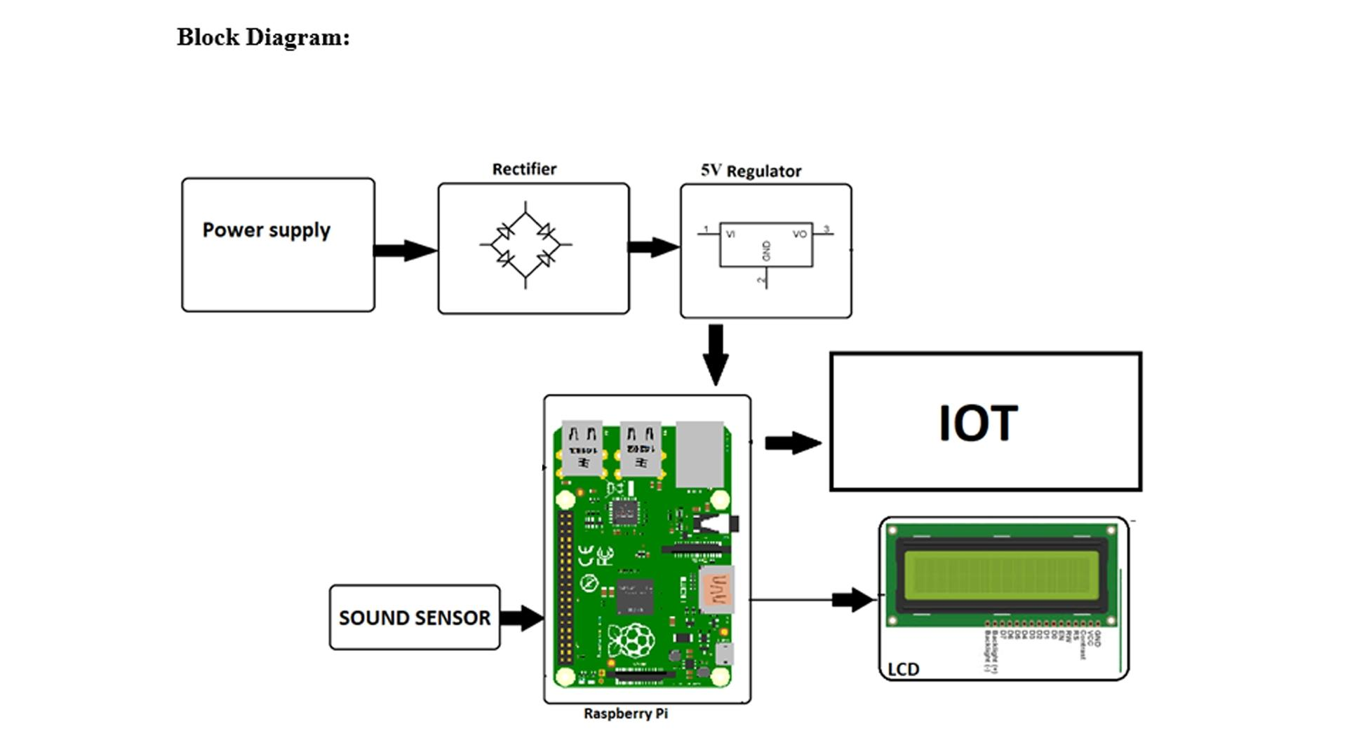

DESCRIPTION:

Sound Capture: Sound sensors or microphones capture ambient sound from the environment.Signal Processing: The raw audio signal is processed to remove interference and unwanted noise.Analog-to-Digital Conversion: The processed analog signal is converted into digital form for easier analysis.Data Processing: The microcontroller processes the digital data to calculate noise levels and other relevant parameters. It may use Fast Fourier Transform (FFT) or other techniques to analyze the frequency components of the sound.Data Storage: The digital data is stored temporarily for real-time monitoring and may also be saved for historical analysis.Display and Communication: Noise levels and relevant data are displayed on a screen or communicated to a central server for remote monitoring.Alarm Generation: If noise levels exceed predefined thresholds, an alarm can be triggered to alert relevant authorities or individuals.Power Supply: The system requires a stable power supply to operate continuously and monitor noise levels effectively.